Lecture: 1.1.2 Algebra of Sets
Course outcome to be covered:
CO1: Apply and recognized about the theory of sets.

Basic Operations on Sets:
There are three major operations performed on sets that are discussed below:
- Union of sets (∪)
- Intersection of sets (∩)
- Difference of sets ( – )
Union of sets:
If two sets A and B are given, then the union of A and B is equal to the set that contains all the elements present in set A and set B. This operation can be represented as;
A ∪ B = {x: x ∈ A or x ∈ B}
Where x is the elements present in both the sets A and B.
Example: If set A = {1,2,3,4} and B {6,7}
Then, Union of sets, A ∪ B = {1,2,3,4,6,7}
Intersection of Sets If two sets A and B are given, then the intersection of A and B is the subset of universal set U, which consist of elements common to both A and B. It is denoted by the symbol ‘∩’. This operation is represented by:
A∩B = {x : x ∈ A and x ∈ B}
Where x is the common element of both sets A and B.
The intersection of sets A and B, can also be interpreted as:
A∩B = n(A) + n(B) – n(A∪B)
Where,
n(A) = cardinal number of set A,
n(B) = cardinal number of set B,
n(A∪B) = cardinal number of union of set A and B.
Example: Let A = {1,2,3} and B = {3,4,5}
Then, A∩B = {3}; because 3 is common to both the sets.
Difference of Sets
If there are two sets A and B, then the difference of two sets A and B is equal to the set which consists of elements present in A but not in B. It is represented by A-B.
Example: If A = {1,2,3,4,5,6,7} and B = {6,7} are two sets. Then, the difference of set A and set B is given by; A – B = {1,2,3,4,5}. We can also say, that the difference of set A and set B is equal to the intersection of set A with the complement of set B. Hence, A−B=A∩B’.

Algebra of sets, Combination of sets, Duality 1.1.2
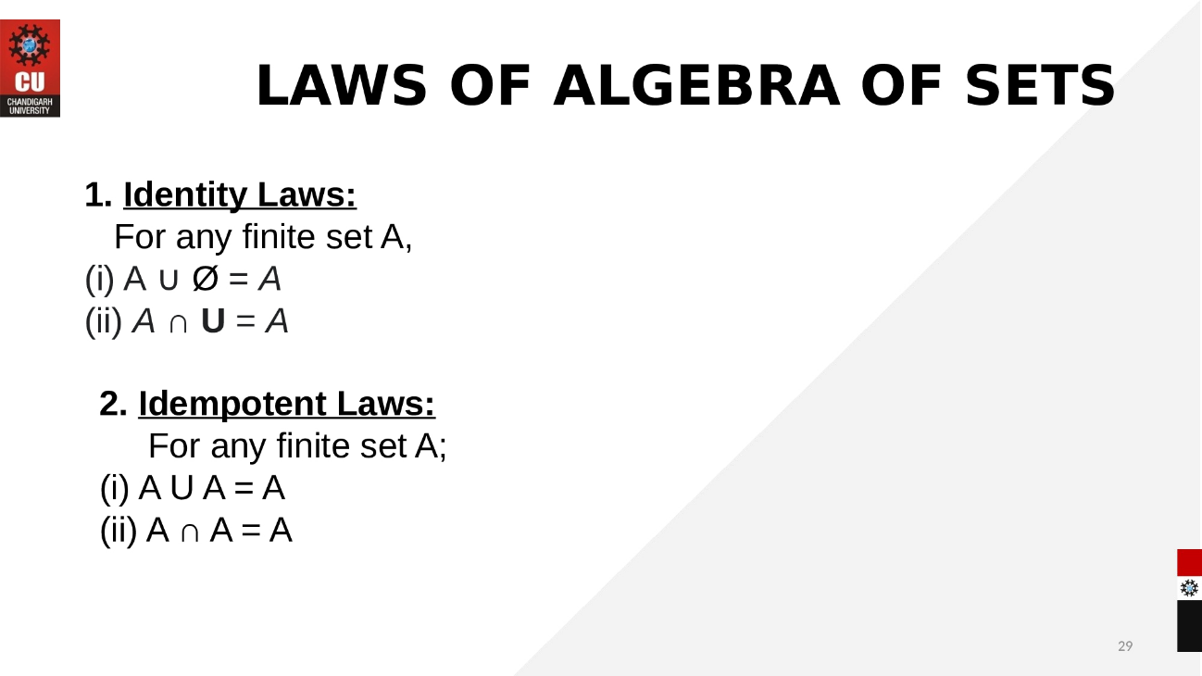

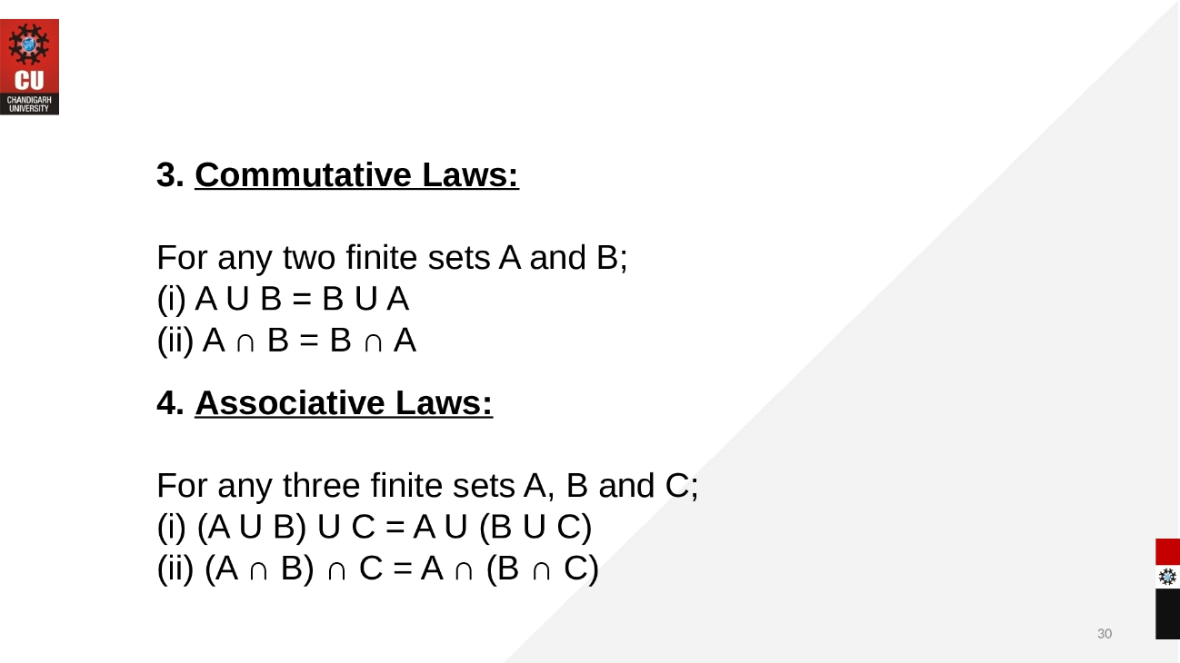
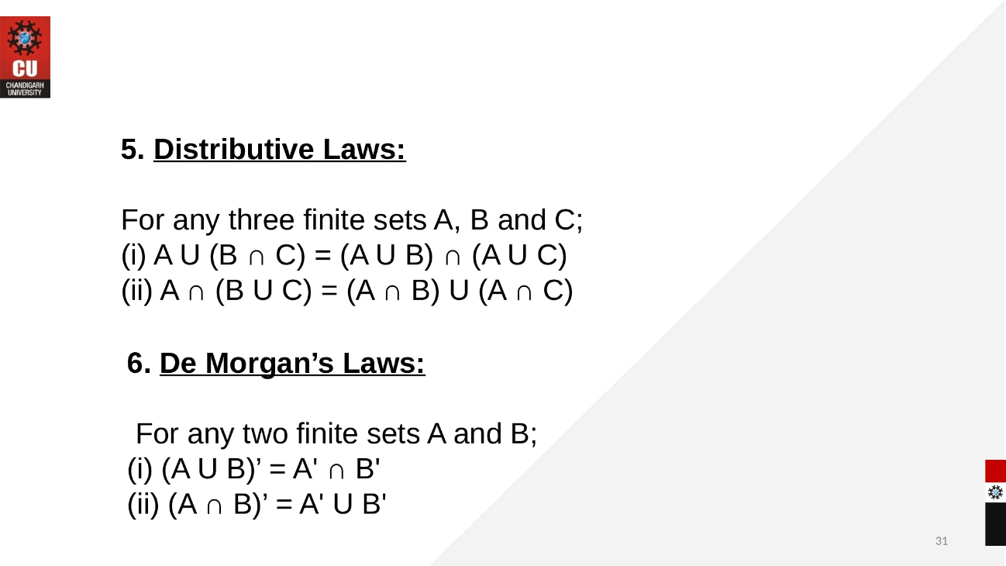

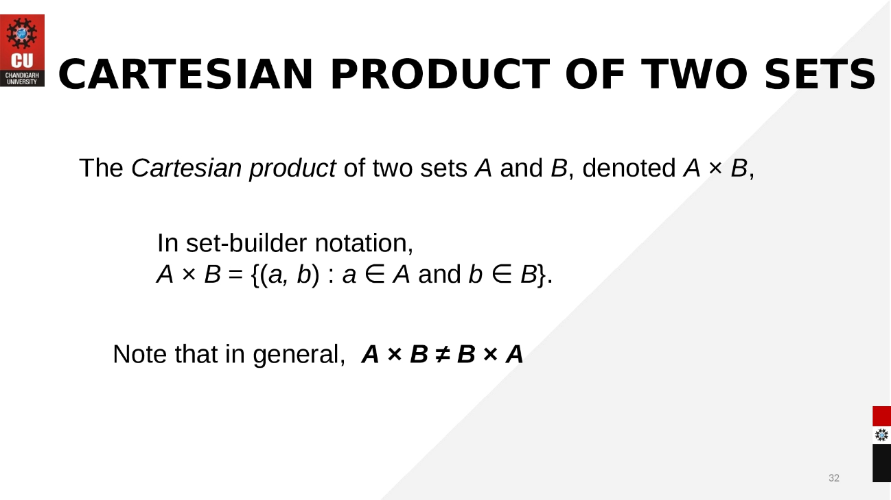
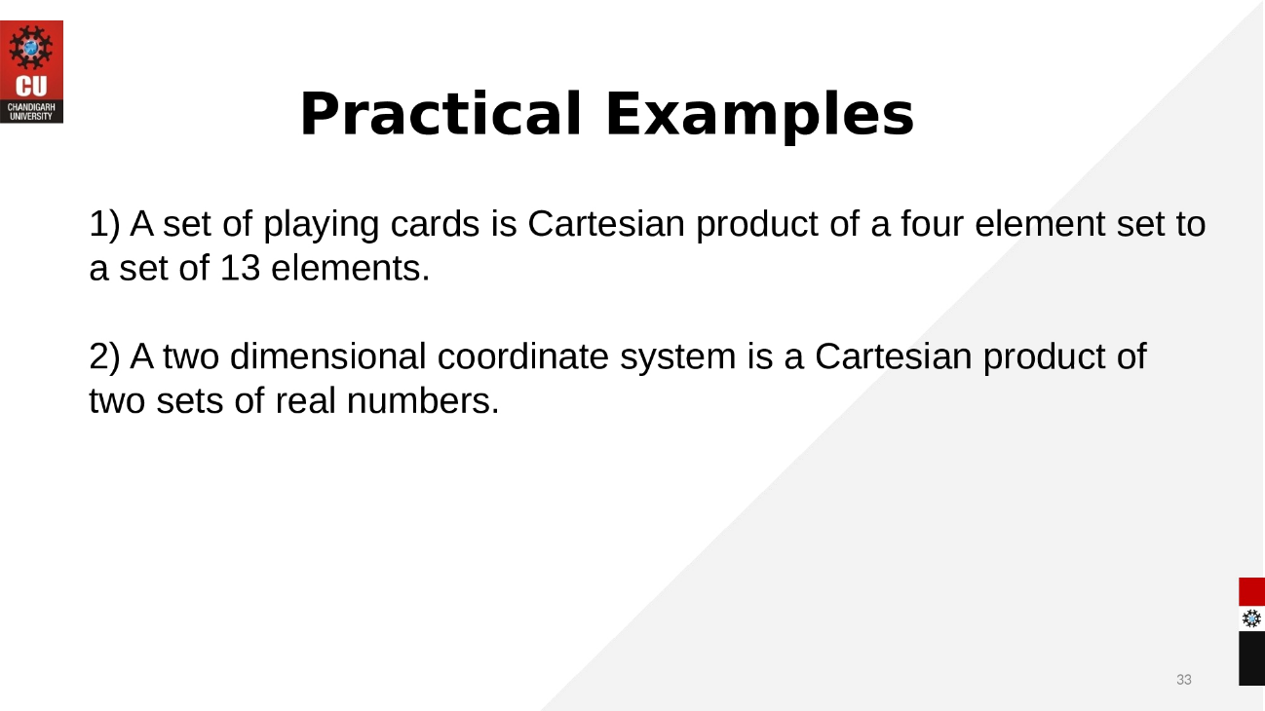

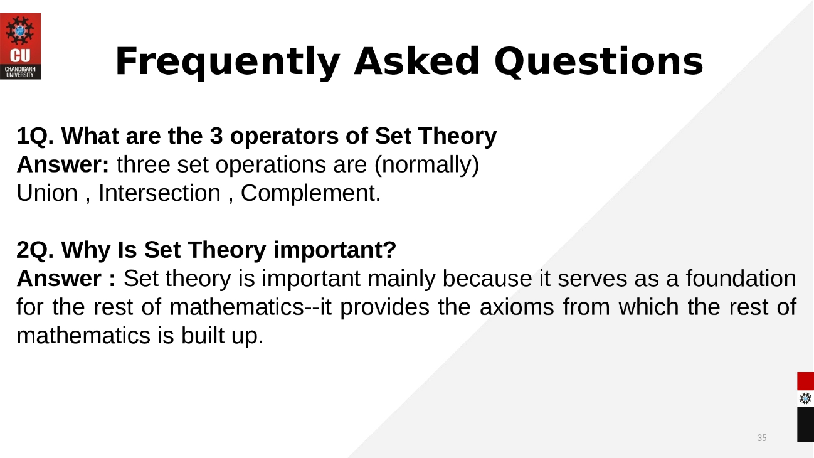

Duality in Linear Programming:
The duality theory in linear programming yields plenty of extraordinary results, because of the specific structure of linear programs. In order to explain duality, we use the example of the smart robber. Basically, the smart robber wants to steal as much gold and dollar bills as he can. He is limited by the volume of his backpack and the maximal weight he can carry. The problem we have written here (no matter which equivalent formulation we used) is what we call the primal linear program.
Duality can also be described as a property that belongs to the branch of algebra. This theory can be called lattice theory. This theory has the ability to involve order and structure, which are common to different mathematical systems. If the mathematical system has the order in a specified way, this structure will be known as lattice.
Principle of Duality in Discrete Mathematics
The principle of duality is a type of pervasive property of algebraic structure in which two concepts are interchangeable only if all results held in one formulation are also held in another. This concept is known as dual formulation. We will interchange unions(∪) into intersections(∩) or intersections() into the union() and also interchange universal set into the null set(∅) or null set into universal(U) to get the dual statement. If we interchange the symbol and get this statement itself, it will be known as the self-dual statement.
For example: The dual of (X ∩ Y) ∪ Z is (X ∪ Y) ∩ Z
The principle of duality concept should not be avoided or underestimated. It has the ability to provide several sets of theorems, concepts, and identities. To explain the duality principle of sets, we will assume S be any identity that involves sets, and operation complement, union, intersection. Suppose we obtain the S* from S with the help of substituting ∪ → ∩ Φ. In this case, the statement S* will also be true, and S* can also be known as dual statement S.

Examples of Duality:
Examples 1:
A ∪ (B ∩ A) = A
When we perform duality, then the union will be replaced by intersection, or the intersection will be replaced by the union.
A ∩ (B ∪ A) = A
Example 2:
A ∪ ((B^{C} ∪ A) ∩ B)^{C} = U
When we perform duality, then the union will be replaced by intersection, or intersection will be replaced by the union. The universal will also be replaced by null, or null will be replaced by universal.
A ∩ ((B^{C} ∩ A) ∪ B)^{C} = Φ
Example 3:
(A ∪ B^{C})^{C} ∩ B = A^{C} ∩ B
When we perform duality, then the union will be replaced by intersection, or intersection will be replaced by the union.
(A ∩ B^{C})^{C} ∪ B = A^{C} ∪ B
Various systems have underlying lattice structures: symbolic structure, set theory, and projective geometry. These systems also contain the principles of duality.

LINKS:
https://youtu.be/7RjEF_EINCc
https://youtu.be/vGelH3Jibt4

ebook Discrete Mathematics
https://vcarrion.people.uic.edu/Pinter%20-%20A%20Book%20of%20Set%20Theory.pdf

